19May26 - GST SAP Vendor

GST SAP Vendor × Mindhive — Meeting Notes
Date: 2026-05-19
Participants: Jermaine (Mindhive CTO), Jun (GST), Sharon, Ling, Hasma
Purpose: Align on MAIA ↔ SAP B1 integration architecture and requirements for GST

Key Point A: Integration Architecture
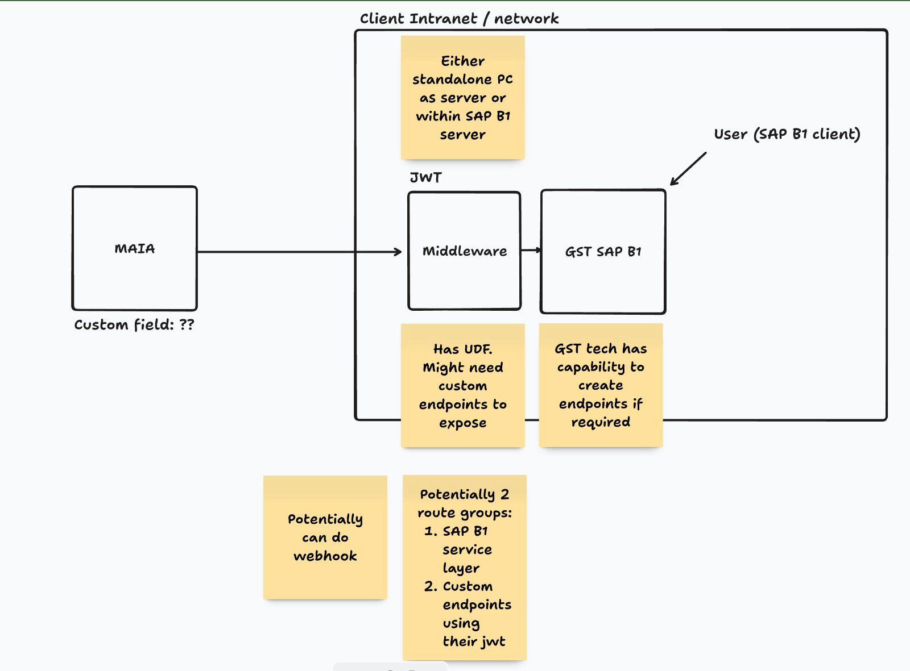
MAIA → Middleware → GST SAP B1 via JWT
MAIA connects to GST's SAP B1 through a middleware layer hosted on GST's client intranet (either standalone PC or within the SAP B1 server). Authentication between MAIA and middleware uses JWT. Two route groups are planned depending on whether standard service layer is sufficient.
Main Point 1 — Architecture layers
- MAIA sends data to Middleware (JWT-authenticated)
- Middleware sits on client intranet — standalone PC or within SAP B1 server
- Middleware forwards to GST SAP B1
Main Point 2 — Two route groups
- Route 1: SAP B1 standard service layer (use first, lower complexity)
- Route 2: Custom endpoints using GST's JWT (for UDFs and custom fields)
Main Point 3 — Open question
- MAIA custom fields (Custom field: ??) still TBD — must be defined before dev starts
- GST tech team confirmed capable of building custom endpoints if needed
- Webhook from middleware also potentially possible

Key Point B: Custom Fields & Endpoint Requirements
GST's SAP custom fields must be mapped before integration can begin
GST uses customized fields in SAP B1 that fall outside MAIA's standard data model. The current service layer cannot pass these fields — new endpoints must be exposed by GST's IT team, and MAIA must provide a field mapping document.
Main Point 1 — Custom field mapping
- MAIA team must collect full list of GST's SAP custom/UDF fields during requirements gathering
- Field mapping document required before any dev work starts
- Coordination between MAIA and GST teams to align data flows
Main Point 2 — Service layer limitations
- Standard SAP B1 service layer cannot support all custom fields
- GST IT must expose new/custom endpoints for those fields
- Two-way data sync required — both sides must match at all times
Main Point 3 — Middleware UDF gap
- Middleware has UDFs; may need custom endpoints to expose them
- Identified limitations will require updating GST custom UDFs to accommodate new elements
- Sync between SAP modifications and middleware must maintain data integrity

Key Point C: Phased Integration Approach
Start with standard service layer; expand to custom endpoints only where needed
Jermaine recommended a phased approach: validate what the existing SAP B1 service layer supports first, identify UDF and custom field gaps, then build custom endpoints only where the standard layer falls short.
Main Point 1 — Phase 1: Standard service layer
- Use current SAP B1 service layer capabilities to handle webhooks and initial data sync
- Map all fields supportable by standard layer first
- Document limitations before proceeding to custom work
Main Point 2 — Phase 2: Custom endpoints
- Build custom endpoints for fields not supported by service layer
- GST JWT used for authentication on custom route
- Webhook triggers on SAP events to be configured in middleware
Main Point 3 — Dev environment setup
- Create dev/UAT server mirroring GST production database
- Mirror: customers, items, warehouse, tax types, discount types
- Validate integration in UAT before any production deployment

Key Point D: Document Flow — SO → DO → Invoice
Delivery Order and Invoice are linked, share numbering, and go out together
GST's order fulfilment flow: Sales Order → picking list → Delivery Order (DO) + Invoice dispatched together. DO and Invoice carry the same document number. DO is printed as triple carbon copy.
Main Point 1 — Document numbering
- DO and Invoice share same document number
- Invoice template used; DO has different layout/title but follows invoice numbering
- Multiple DOs can be created under one Sales Order
Main Point 2 — Triple carbon copy
- DO printed as 3 copies: white copy + customer copy + carbon copy
- DO and Invoice dispatched together with delivery
- Returning DO = carbon copy (confirmation of receipt)
Main Point 3 — Picking list → dispatch flow
- SO triggers picking list generation
- Warehouse staff key in packing weight on picking list
- DO only sent after weight confirmed
- Inventory deducted at DO dispatch (not at SO creation)

Key Point E: Order Fulfilment & Inventory Management
Warehouse packing data drives inventory deduction; SAP stock transformation handles raw-to-finished goods
Inventory is deducted in real time based on actual packed weights recorded by warehouse staff. GST also has a custom SAP stock transformation feature that converts raw stock (e.g., whole fish) into finished goods (e.g., portioned by weight) — this must be mapped into the MAIA integration.
Main Point 1 — Inventory deduction logic
- Warehouse staff record weight during packing on picking list
- Inventory deducted only when DO is sent (actual shipped qty)
- Ensures inventory reflects real dispatched quantities, not ordered quantities
Main Point 2 — Stock transformation (custom SAP feature)
- Custom SAP feature: raw stock → finished good (1:1 transformation)
- Example: whole salmon → portioned salmon by weight
- Transformation triggered on customer order (SO creation)
- MAIA must reflect transformed item on SO/DO/Invoice
- Inventory must track both raw and finished good stock
Main Point 3 — Customer ordering channels
- Orders received via WhatsApp, email, verbal (hotel accounts)
- No formal PO at order placement for some customers
- PO still required for payment reconciliation — must be collected before or shortly after order

Key Point F: Payment & Return Note Handling
Multiple invoices per payment entry supported; return notes and refunds must link accurately
GST's payment flows are complex — single payments can cover multiple invoices, partial knock-offs are supported, and return notes/refunds must be linked back to the correct invoice records.
Main Point 1 — Payment entries
- System supports payment entries across multiple invoices
- Partial knock-off (partial payment against invoice) confirmed supported
- Return notes must be carefully linked to correct invoices
Main Point 2 — Refund handling
- Refunds processed via payment entry after return note created
- Return notes and refunds integrated to maintain accurate financial and inventory records

Key Point G: SAP UAT Environment & Testing
Access to SAP UAT instance with production-mirrored data is the critical next step
Integration testing cannot begin without a dedicated UAT environment. GST's IT team must provision SAP UAT instance access for MAIA. Testing scope covers stock receiving, item production, and manufacturing report generation.
Main Point 1 — UAT environment requirements
- MAIA team needs access to SAP UAT instance including data logs
- Data must mirror production: customers, items, warehouse, tax types, discount types
- GST IT team to provision access — flagged as dependency
Main Point 2 — Testing scope
- Stock receiving and item production flows
- Manufacturing report generation
- SAP signal-based triggers and MRP manufacturing process evaluation
- Minimum stock level monitoring (1000kg threshold referenced)
Main Point 3 — Security constraints
- GST enforces strict IT security protocols — complicates server access
- Permissions must be clarified with IT before environment can be fully explored
- High security necessary to protect production data

Next Steps
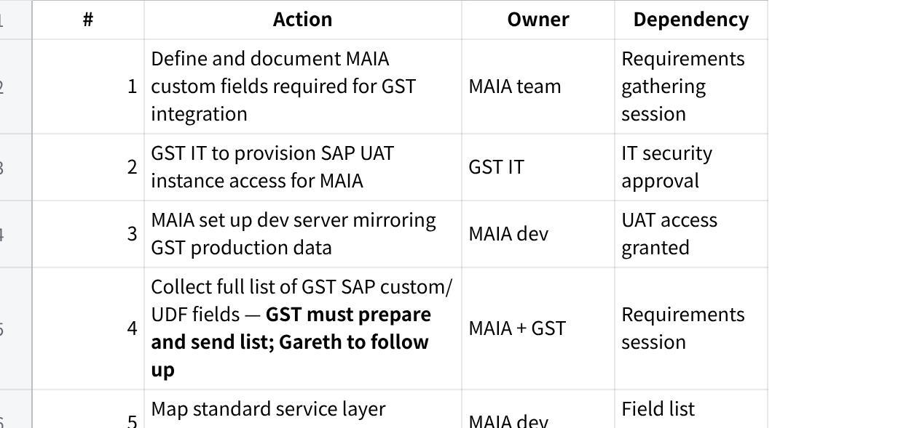
点击图片可查看完整电子表格

Next Action Items
Gareth (Product)
- Follow up with GST — request full list of SAP custom/UDF fields
- Schedule requirements gathering session (custom fields, stock transformation rules, document numbering conventions)
MAIA Dev (Jermaine & Azib)
- Set up dev server mirroring GST production data (after UAT access granted)
- Map SAP B1 standard service layer coverage vs custom endpoint gaps (after field list received)
- Configure webhook triggers on middleware once base setup done
GST IT
- Provision SAP UAT instance access for MAIA team
- Prepare and send full list of SAP custom/UDF fields
- Build custom endpoints for fields not supported by standard service layer (after field mapping confirmed)

